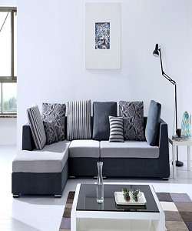

Modern Style Poliform sofa

$112.67

Availability: In stock

Description

Latest L shaped grey and black sofa set with couches. The ultimate in relaxation, the large scale of our L shape sofa make you in comfort. Tall bake cushion offers plenty of head and neck support.no-requirement available.